Dear Parents,
Christ School and the Buncombe County Public Library are partnering to support students’ ongoing education. We share the belief that a love of books and learning is a strong foundation for student success and we are working together to provide every Christ School student access to books and resources found at their public library.
Beginning October 1st, 2022, all Christ School students will be able to use their Student ID number to access and borrow public library books and access digital resources. This initiative is called StudentAccess.

Question: How will a student use their student ID account?
Answer: Students will use their school ID number and PIN to borrow books or access the library’s services like e-books and online research. The default PIN is the last 4 digits of the student ID number.
Question: What can a student do with a student ID account?
Answer: Student ID accounts allow students to borrow e-resources and access library databases just like any other Buncombe County Public Library card. Students can also borrow up to 10 print or audio books from the Buncombe County Public Library collection.

Question: Is the student account free?
Answer: Yes, the student account is free. There are no overdue fines for student accounts, but students are responsible for any fees on lost or damaged books.

Question: How do I sign my child up for a student ID account?
Answer: You don’t need to take any action to get a student ID account for your child. All Christ School students will automatically be enrolled in this program.

Question: What if I don’t want my child to have a student ID account?
Answer: If you do not want your child to have access to library materials, you may opt out. See the attached document for an opt-out form you can sign and send to Tina Evans, Director of Academic Resources (tevans@christschool.org).

Question: What if my child already has a Buncombe County Public Library card?
Answer: Students may have both types of accounts.

For more information, email tevans@christschool.org.
This project was made possible in part by the Institute of Museum and Library Services
and the State Library of North Carolina.

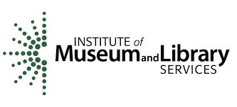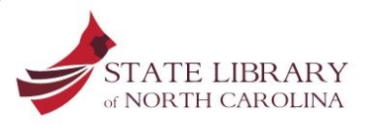

StudentAccess Parent Opt-Out Form

If you want your child to participate in StudentAccess, then you do not need to do anything. Your child will automatically be enrolled.
If you do not want your child to participate, then please complete this parent opt-out form and email it to tevans@christschool.org.
Child’s Name (Please print)
School
Grade
Student ID Number
Parent or Guardian’s Name (Print)
Phone Number

By signing this form, I understand my child will not have a student ID library account and PIN to be able to participate in classroom use of library resources.

Parent/Guardian Signature Date

